Creating a Multi-Module Maven Project:
- Open eclipse-> file-> new -> other -> Maven -> MavenProject ->click on next.
- Check the first option: Create a Simple project(skip archetype selection) and click on next.
- Give groupID: KMIT, artifact ID: MultiModule, in the packaging tab select the drop down and opt for pom.
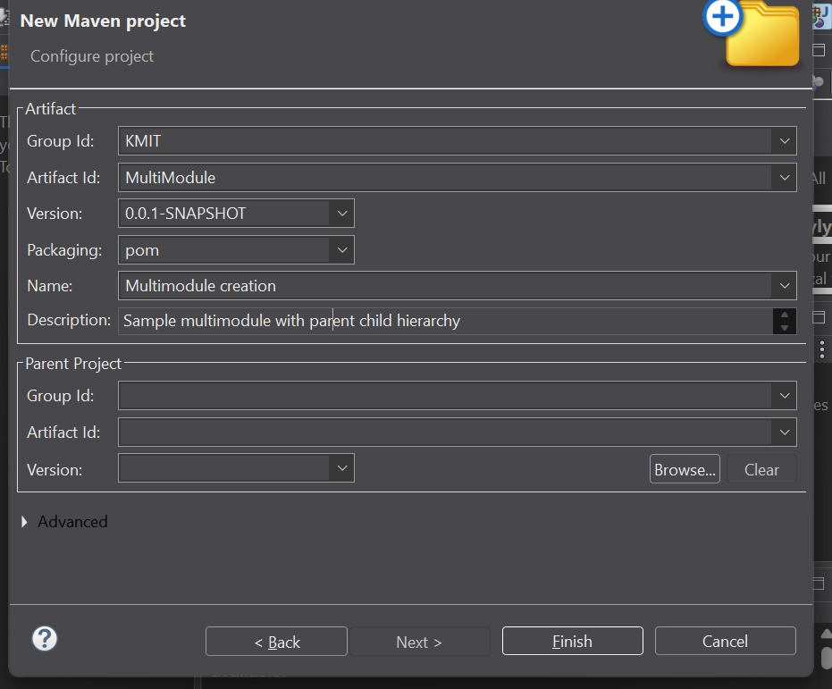
- Give Name: Multimodule creation and Description: Sample multimodule with parent child hierarchy and click on next.
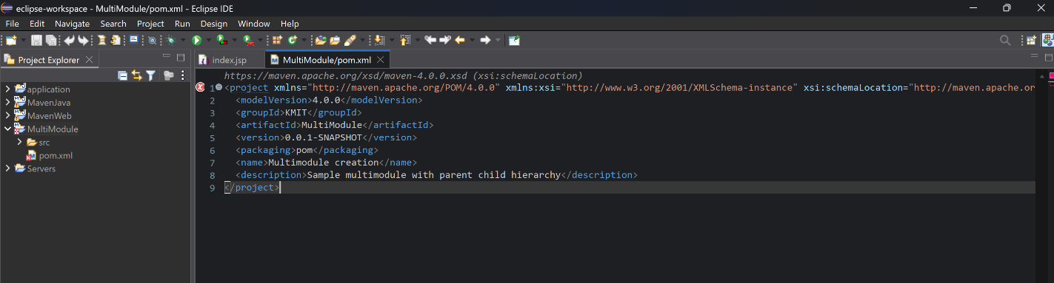
- Now the Multimodule folder is created and displayed in the project explorer on the left. Right click on the folder and opt new -> mavenModule
- Check the option Create a Simple project(skip archetype selection, give the artifactID: MultiModuleChild1 and click on next and finish.
- Now you can see, the module1 we created is displayed in the project explorer with a separate pom.xml file.
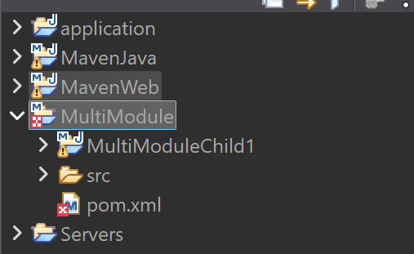
- . Right click on the MultiModule folder in the project explorer and opt new -> mavenModule
- Give the artifactID: MultiModuleChild2 and click on next.
- In filters search for maven-archetype-webapp, select the version 1.1/1.5 and click on next.
- Now click on finish, and confirm with a Y in the console.
- Now you can watch the new child is been added to the parent project.
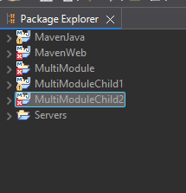
Note: Childs or Modules can be added to the projects who have the packaging type as pom. If we try to create a module within child1 it is not possible since its packaging is opted to JAR.
Linking two modules in a Parent Project:
Go to the module u want to connect. And add a dependency to other module on which the current module depends. For example if my child2 is dependent on child1. I have to change the dependencies in the pom.xml by adding a new dependency of child1.
Steps to add dependency:
- Goto pom.xml of child2.
- Navigate to dependencies tag. Update the dependencies with child1 dependency as given below, and save pom.xml after update.
<dependency>
<groupId>KMIT</groupId>
<artifactId>MultimoduleChild1</artifactId>
<version>0.0.1-SNAPSHOT</version>
</dependency>
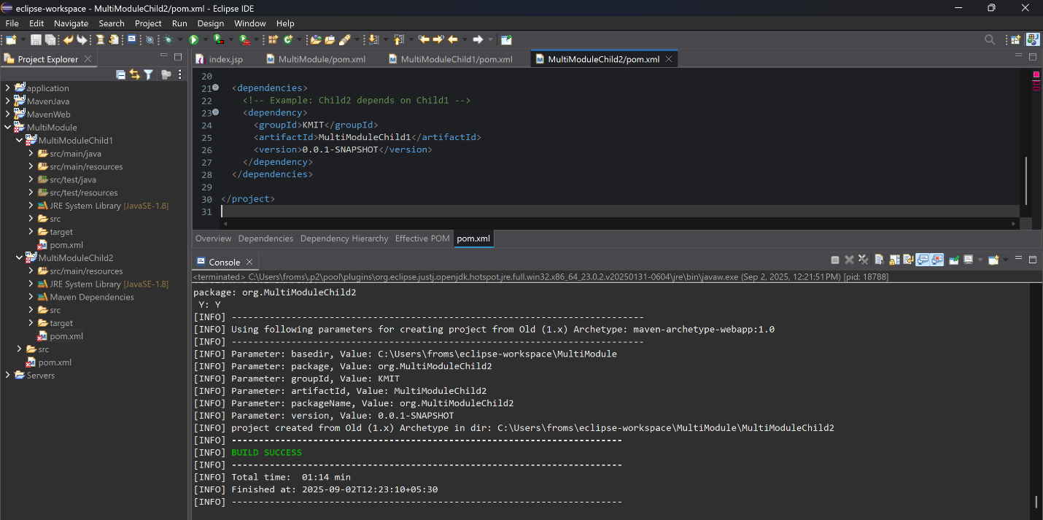

- Now build the child2 by right clicking it and opting run as->maven build.
- The build will be a failure. Because we haven’t build the parent project and the child project. Child1 is dependent on parent. And Child2 is dependent on child2. SO we have to build ass the previous module first and then build the current child2.
- After building parent and child1, build child2 now the build will be a Success

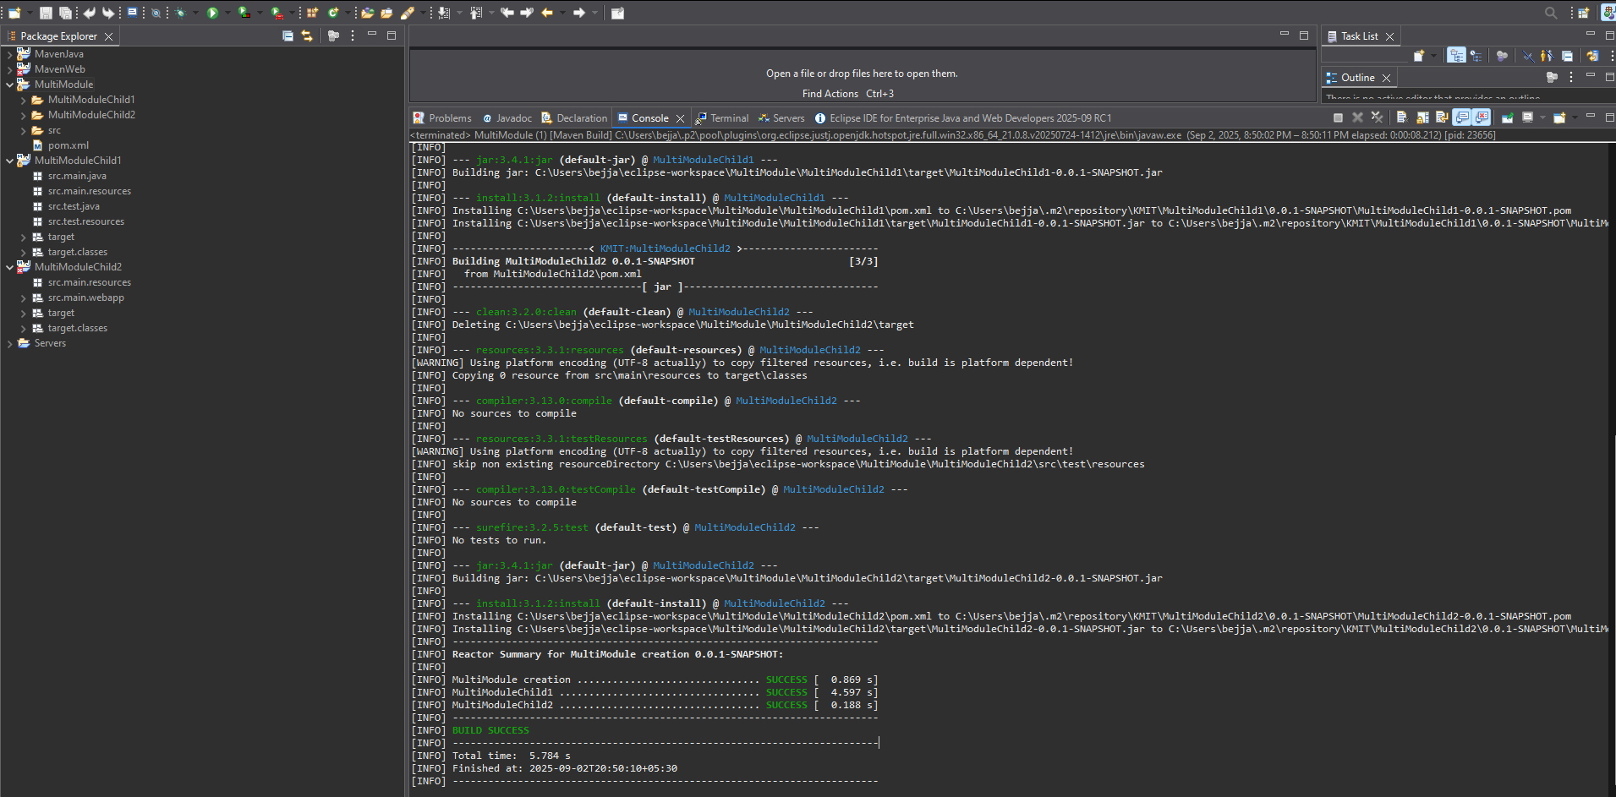

Scenario-Based Questions:

- If my error is about:
Failed to execute goal org.apache.maven.plugins:maven-compiler-plugin:3.8.1:compile
[ERROR] -> [Help 1]
[ERROR] To see the full stack trace of the errors, re-run Maven with the -X switch.
How can I resolve it using maven terminal?

Command : mvn clean compile -X

- A dependency you added is not recognized by the compiler. What steps would you take to confirm it is available in .m2 and listed in dependency tree?

Command : Run mvn dependency:tree and check .m2/repository for the dependency.

- A teammate sends a .patch file for a bug fix. How would you apply it and include it in your Maven build?

Command : Apply with git apply bugfix.patch then commit, rebuild with mvn clean install.

- You have multiple JUnit test failures and want to rerun only failed tests. How would you approach this?

Command : Use mvn surefire:test -Dtest=failedTestClass#methodName or rerun via surefire rerun plugin.

- Your Maven build fails due to “Unsupported class version error.” What plugin and configuration would you review?

Command : Check <maven-compiler-plugin> version and set correct <source>/<target> or <release>.

- You need to change your Java application from a WAR to a standalone JAR. What pom.xml changes are needed?

Command : Change <packaging>jar</packaging> and configure maven-jar-plugin or spring-boot-maven-plugin.

- You are required to change the default build output directory from target/ to build_output/. How would you configure it?

Command : Add <build><directory>build_output</directory></build> in pom.xml.

- You want to skip tests during the Maven build. What command would you use?

Commmand : Run mvn clean install -DskipTests or -Dmaven.test.skip=true.

- How would you generate a site report (with test coverage, dependency analysis) for a Maven project?

Command : Run mvn site with reporting plugins like jacoco-maven-plugin.

- How do you build a Java project using Maven, and what files are generated in the target/ folder after running mvn clean install?

Command : Run mvn clean install; it generates *.jar/war, classes, and reports in target/.

- How does Maven resolve dependency conflicts when two libraries use different versions of the same dependency, and how can you view and manage the dependency tree?

Command : Maven uses “nearest definition” rule; inspect with mvn dependency:tree -Dverbose.

- How do you write and run a JUnit test in a Maven project, and where are the compiled test classes and reports stored after running mvn test?

Command :Write JUnit in src/test/java, run mvn test; classes go to target/test-classes, reports in target/surefire-reports.

- How can you create an executable JAR with a main method using Maven, and which plugin helps configure this behavior?

Command : Use maven-jar-plugin or shade-plugin with <mainClass> to build executable JAR.

- How do you install and use a custom third-party JAR file in your Maven project, and how can you confirm it’s included in the build and classpath?

Command : Install with mvn install:install-file and confirm via mvn dependency:tree.

- How do you create a Maven web project that packages into a WAR file, and what is the standard folder structure for such a project?

Command : Use mvn archetype:generate with maven-archetype-webapp, structure has src/main/webapp for JSP/WEB-INF.

- What command do you use to build a WAR file in Maven, where is it generated, and how can you deploy it to a server like Apache Tomcat?

Command : Run mvn package, WAR goes in target/, deploy by copying to Tomcat’s webapps/.

- How do you add JSTL and servlet-api dependencies in a Maven web project, and why should the servlet API use provided scope instead of compile?

Command : Add javax.servlet:jstl and javax.servlet:javax.servlet-api with <scope>provided</scope> to avoid bundling container classes.

- How do you set up a multi-module Maven web project with separate modules for core logic and web interface, and how are these modules built and connected?

Command : Create parent POM with <modules>, define core (jar) and web (war) modules, build parent with mvn install.

- How do you configure a Maven web project, and how does its packaging and execution differ from a traditional WAR-based application?

Command : Configure <packaging>war</packaging> and web.xml/webapp resources; WAR is deployed to a servlet container unlike a standalone JAR

